Roaming Around Reidsville

By Angela G. Stadler

Public Information Officer

City of Reidsville

For the past several years, the City of Reidsville has been focusing on what is considered a great quality of life issue for its residents – walkability. Now, having been cooped up in our homes for so long due to COVID-19, we are eager to get out and get some exercise. Nothing is better than walking and focusing on the nature that can be found in the heart of the City.

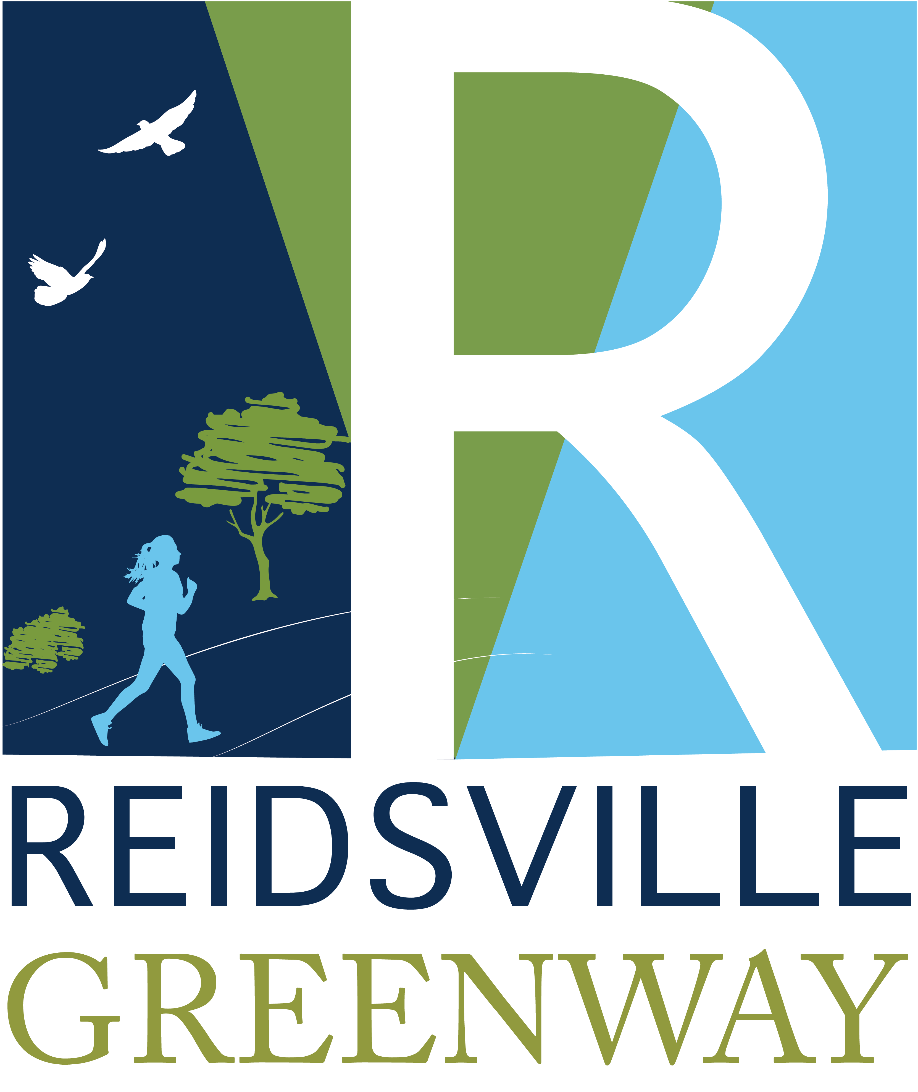
The City of Reidsville started working on its greenways plan more than two decades ago. A committee of City staff and Council members, along with residents, were given the go-ahead in 1997 to continue planning and to start looking for sources of funding. The plan called for a network of trails to crisscross the City, eventually going all the way down to Lake Reidsville, built in a series of phases.

Part of that vision has already come to fruition. In the heart of Reidsville you will find two paved greenway trails – Jaycee Park and Sherwood. The Jaycee Park Trail is 1.3 miles long and connects Reidsville Middle School and Reidsville High School with the Jaycee Park recreational area. The Jaycee Trail was the first greenway to be constructed in Reidsville. The Jaycee Trail Extension takes you a little farther to lower Jaycee Park located on South Scales Street. The .78-mile Sherwood Trail connects Courtland Park to Sherwood Drive.

Have you ever been out to Lake Reidsville? The lake offers trails to walk and to bike. Beginning in 2020, work began on a 2.25-mile trail extension to add to nearly three miles of existing hiking and biking trails. Fingers crossed, but that project is scheduled to be completed this month. For the hiker who loves to take the natural trail route, this one’s for you. You might catch a glimpse of the beautiful bird life there since Lake Reidsville is on the North Carolina Birding Trail.

During its 2018 Retreat, the City Council directed staff to begin updating the Greenway Plan and expanding the document to include Blueways. Among the greenway plans are to extend the Jaycee Park Trail even further. This greenway will be a natural trail that will connect the existing trail in the vicinity of the Reidsville High School football field to the sidewalk parallel to Freeway Drive, making the total trail approximately .68 miles long. These plans also call for two separate natural trails that will connect Sherwood Drive to Freeway Drive. The updated plan also includes a trail that was in the original – the Lowes Greenway Trail. Approximately .66 miles on length, the natural trail will connect the Lowes Ballfield to the Reidsville Recreation Center and RCARE.

Other natural trails are also proposed for the Liberty Road area and four phases of trails that will connect neighborhoods, such as Reid Lake Road, McCoy Road, the U.S. 158 area and Iron Works Road, to Lake Reidsville. All of these Lake Reidsville trails will play into the City’s plans to become part of the Mountains-to-Sea Trail, a long-distance trail for hiking and backpacking that goes from the Great Smoky Mountains to the Outer Banks.

If you enjoy walking shorter distances and learning history along the way, we have mentioned in past articles about ways you can explore downtown Reidsville and its historical areas. This column took its name from the City of Reidsville’s QR Code Video project that launched in 2018. Residents and visitors alike can download a free QR Code app to their smartphone, click on the QR Codes found on downtown directional signs or at local attractions, and see short videos about the location. We have “Roam Reidsville” informational cards available at City Hall, 230 W. Morehead Street, or you can print the cards by going to the City website, www.reidsvillenc.gov. The City’s Historic Preservation Commission has a walking tour showcasing historical buildings in Reidsville. The informational brochure is available online on the City website or at City Hall.

Next month we’ll talk about the other component of the plan, the City’s Blueways.

In other news, what’s happening in the City of Reidsville during the month of August?

2nd Downtown Fridays!

Last month’s 2nd Downtown Fridays was a blast! If you didn’t make it out in July, you can come to downtown Reidsville on Friday, August 13, to hear music, enjoy the kid’s zone and food vendors and of course, see all those fabulous vintage vehicles. The Reidsville Chamber of Commerce is providing a beer garden during the event. Hours are 6 p.m.-9 p.m., rain or shine.

Concerts on the Square.

The Summer 2021 concert series at Market Square, 303 S. Scales Street, in downtown Reidsville in August will showcase the band Radio Revolver, which will provide those attending with some classic rock. The concerts start at 7 p.m. until 9 p.m. on Saturday, August 28. Don’t forget to bring your chair. The Chamber of Commerce will provide a Beer Garden at the concert. You can go to www.reidsvillenc.gov to find out more.

Water Wednesdays.

Starting in July on every Wednesday and continuing through August 11th, the Fire Department, Police Department and Parks & Recreation have been opening up hydrants at specific City parks to provide residents with a refreshing spray! There are free ice pops as well. On August 4, they will be at Cambridge Park and on August 11, at Courtland Park. Times are 1-2:30 p.m. Check out the City’s social media (City of Reidsville, Team Reidsville and Reidsville Parks & Recreation Facebook pages) for more details for “Water Wednesdays” closer to the dates.

Rec Football Registration Begins.

The Reidsville Parks & Recreation Department opened registration July 26th for the Rec Football League for ages 7-9 & 10-12. You can sign up online at http://activenet.active.com/reidsvillerec or call 336-349-1090 until Sept. 10th.

Fitness on the Square.

For those who have been stuck at home, here’s the chance to get some exercise. “Fitness on the Square” at Market Square in downtown Reidsville began in May and continues through September. Class times have changed to 6:30-7:30 p.m. “Pound” classes are held on Mondays and “Bootcamp” on Thursdays. Pound is a full body cardio-jam session using drum sticks (provided) while Bootcamp is interval training mixing calisthenics, body weighted exercises, cardio and strength training. Bring a mat, towel and water! Email downtown@reidsvillenc.gov. Funded in part by Cone Health.

Farmer’s Market.

Don’t forget! The Farmer’s Market at Market Square in downtown Reidsville is open! Come get your fresh veggies and more at the market, open from 7 a.m. until 1 p.m. Saturdays, Tuesdays & Thursdays. EBT customers can double their benefits with no cap!

