**Roaming Around Reidsville**

**By Angela G. Stadler**

**Public Information Officer**

**City of Reidsville**

Reidsville’s year-long 150th celebration began officially on Saturday, January 7, 2023, at the corner of South Scales and Williams streets as the City dedicated its new Sesquicentennial Clock Tower. The event drew current and former City officials to the dedication held at 2 p.m. It was great to hear the ringing of the two o’clock bells coming from the clock to start the ceremony for a project that has been years in the making.

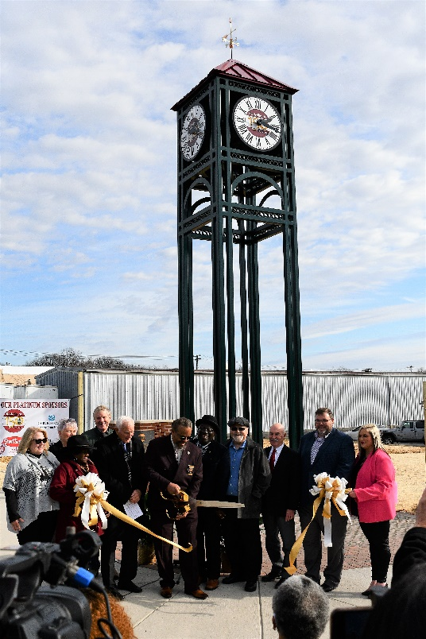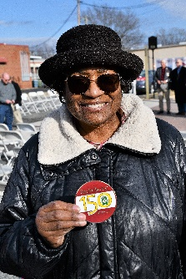

**City officials**, above, cut the ribbon on Reidsville’s new Sesquicentennial Clock Tower. At left, Dr. Jacqueline Chestnut found the first Sesquicentennial Medallion at the January 7th event.

City Manager Summer Woodard recognized special guests on hand, including the past three City Managers, Kelly Almond, Michael Pearce and Preston Mitchell and former Mayor John M. “Jay” Donecker.

Following an invocation by Fire Chief David Bracken, Police Chief Ray Gibson announced the Presentation of Colors done by a combined police-fire squad. The flag was raised across the street at the 9/11 Memorial while the National Anthem played from the clock tower.

State Representative Reece Pyrtle then read from the 1873 Act to Incorporate the Town of Reidsville before Mayor Donald L. Gorham provided remarks.

The Mayor talked about how those first officials must have felt about the opportunities in the new town. “The combination of the railroad and tobacco provided an opportunity for growth and made the founders want to incorporate,” he said. “And Reidsville did grow. The town became a City, a more diverse City, because there was opportunity for all.”

Mayor Gorham ended by saying, “During 2023, we will be looking back at the past, but we will also be looking toward the future. We have several new projects we plan to launch this year, and we believe we have opportunities for growth within our reach. I look forward to seeing what is in store for Reidsville – what I like to call “the best City in all of North Carolina.”

Following the Mayor’s remarks, a ribbon cutting coordinated by the Reidsville Chamber of Commerce was held. Assistant City Manager Chris Phillips then concluded the ceremony by briefly discussing upcoming events and inviting everyone to attend a reception held at the Fire Department.

Phillips also shared that the clock tower is on the site of the former First Baptist Church building. Established in 1874 one year after the incorporation, First Baptist is recognized as the oldest African-American congregation in Reidsville and was listed on the National Register of Historical Properties in 1986. When creating the foundation for the clock tower, several bricks from the former church were unearthed. A picture of the church and its Historical Marker, along with one of the bricks, were among the exhibits on display across the street at Fire Station No. 1 following the ceremony. Other displays also centered on the City’s Mayors and City Councils as well as a table featuring the free Sesquicentennial Calendars, and other giveaways.

The Assistant City Manager recognized our Sesquicentennial sponsors: Platinum level, Cone Health/Annie Penn Hospital; HomeTrust Bank; Reidsville Chamber of Commerce; Short Sugars Pit Bar-B-Q; and Tri-State Steel; and Silver level, Arthur’s Jewelry; Big Apple Supply; Blue Sky Realty; Century 21/The Knowles Team; Car Needs; First Carolina Bank; Pennrose Carwash; Reid’s Computer Sales & Service; Councilwoman Sherri Walker; Strader’s Shoe Store; Reidsville Christian church; The Penn House; Reidsville Downtown Merchants Association; Reidsville Trading Post; Truist; Horizon Mortgage. Bronze and Patron Levels are Powell Barefoot Insurance; Knowles Management & Rentals; Wilkerson Funeral Home; Coates Collectibles & Antiques; Mount Jubilee Ministries; McLaurin Funeral Home; La Boutique; Blessings by the Bushel; and Pelham Transportation. Friends include Mish Mosh; Ole Corner Store; Scales Street Music; Dr. Jay & Anne Donecker; Citty Funeral Home; Leigh Anne & Scott Bassinger; and Sherri Walker.

Phillips pointed out that a Sesquicentennial Medallion will be hidden at each official event. Dr. Jacqueline Chestnut was the first such recipient, finding the medallion underneath a chair at the clock dedication.

At each Sesquicentennial event this year, the calendars will be available until they run out, along with other special giveaways tied to the 150th celebration. The clock tower dedication was one of two events held in January. The City’s Wastewater Treatment Plant was opened for tours on Saturday, January 21.

Events planned throughout February include:

* 9-12 Noon, February 17, 2023, RCARE/Senior Center, 102 N. Washington Avenue, & Parks & Rec Building, 201 N. Washington Avenue, Open House & Tours: Explore the opportunities for fun and learning for young & old at these recreational facilities.
* 10 a.m., February 17, 2023, RCARE/Senior Center: Mayor Donald Gorham and fellow Council members will be talking about African-American influences on City government as part of the Black History Month program.