Roaming Around Reidsville

By Angela G. Stadler

Public Information Officer

City of Reidsville

The City of Reidsville wishes each and every one of you a Happy New Year as 2022 kicks into high gear this month. We hope you all had a wonderful Christmas and were able to celebrate, as much as possible, with family and friends.


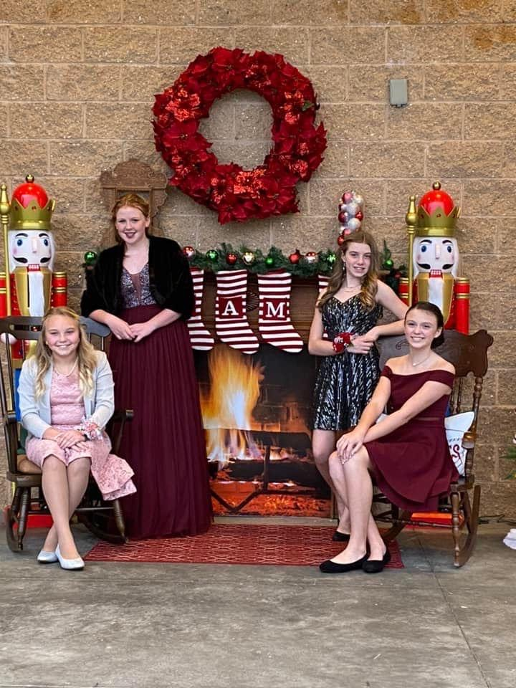
But before we put 2021 behind us, we wanted to pay homage to a new offering in downtown Reidsville this past holiday season that drew visitors from around the State. Reidsville launched its new Holiday Selfie Tour, complete with seasonal-themed decorations throughout the downtown area. These selfie stations were up and running just in time for the City’s Hometown Christmas event on December 3.
Picture Perfect! Great photos, by both citizens and by area professional photographers, were made at the City’s Holiday Selfie Stations this past December. Thanks to all who kindly shared with us their beautiful holiday photos!

The brainchild of City Manager Summer Woodard, these photo opportunities were a hit with both residents and visitors and served as a beautiful backdrop for their perfect holiday picture. Market Square, Mural Park, Kelly’s Way and Abstract Alley … each had unique decorations that were “postcard perfect” for photos.

Manager Woodard had done similar displays in her former hometown of Franklin, North Carolina, and she brought the idea to downtown Reidsville. A Decorations Committee of personnel from across City departments worked to bring her vision to reality. Mrs. Claus’ kitchen at Mural Park … check! Toy Soldiers at Kelly’s Way … check! Lighted trees and star at Abstract Alley … check! But the greatest display was undoubtedly at Market Square, where the area was transformed into Holiday Central. There were photo backdrops for Reidsville’s moniker as the “Football Capitol of North Carolina” and for the historic Penn House. Thanks to Public Services Director Lindsey Tuttle, a camper, tractor and old car were decorated to give visitors a one-of-a-kind photo opp. These holiday spots proved so popular that they drew professional photographers and families to downtown Reidsville for the perfect picture.

People shared their photos with our TEAM REIDSVILLE Facebook page, and we saw some really spectacular shots. This Holiday Selfie Tour is definitely here to stay, and we are looking forward to Christmas 2022!

In other news around the City of Reidsville:

Toymakerz Tour.
Be on the lookout soon for information on the next tour featuring the City of Reidsville. This self-guided driving tour will highlight area locations associated with the popular television series Toymakerz, which is filmed right here in Reidsville. More to be forthcoming!

Event Hotline.

The Downtown Reidsville Event Hotline details upcoming events. You can call 336-347-2381 to find out what’s happening in the downtown area.

Board & Commission Openings.

The City of Reidsville is always looking for residents committed to their community and willing to serve on our boards and commissions. All positions are appointed by either the Mayor or the Reidsville City Council. Interested? You can check out the openings on the City website, www.reidsvillenc.gov.

