Roaming Around Reidsville

By Angela G. Stadler

Public Information Officer

City of Reidsville

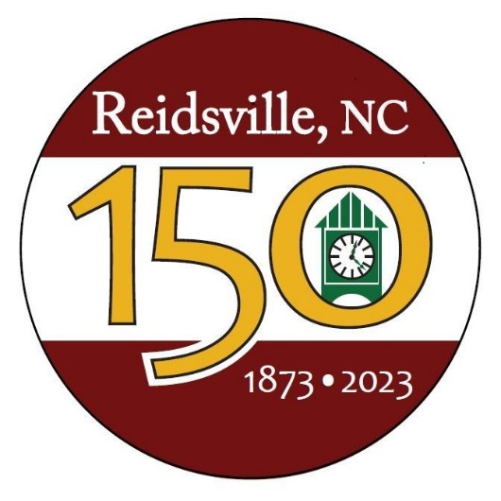
Like everything else in our lives, COVID-19 has really hampered the City’s efforts to plan for our Sesquicentennial in 2023. But our Committee is going full throttle trying to get our activities and plans ready for the City of Reidsville’s 150th Birthday.

We have been planning a year-long celebration, creating new events and tying in our Sesquicentennial theme with existing events and activities. The kickoff will be the “unveiling” of our Sesquicentennial Clock Tower at the corner of South Scales and Williams Streets across from Fire Station #1 in January of 2023. This will tie in nicely with the 9/11 Memorial at the front of the fire station. Combined together, the Clock Tower and the 9/11 Memorial help create a defined entrance at the southern end into our downtown area. And our new Sesquicentennial logo ties in the new clock tower beautifully!

Working hard on the Reidsville150 project are Chris Phillips, Assistant City Manager of Administration/Finance Director; Judy Yarbrough, City Marketer; Leigh Anne Bassinger, HR Director; Donna Setliff, retired Community Development Manager; and myself. We are currently establishing the partnerships needed to pull off a project of this size, enlisting the help of community members, some of our boards and commissions and others.

We are currently looking into possible publications to showcase for the celebration. The key is to have enough historical photos to include. Unfortunately, as the years pass by, we are losing a lot of our older citizens and their access to such photographs. If you have anything you’d like to add either in photos, ideas or items for the Sesquicentennial, you can email us at Reidsville150@reidsvillenc.gov.

Among the ideas are Founders Day/1873 at the Governor Reid House with old-timey games and period-dressed performers; a lawn party at the Penn House centered around the music and dress of the Roaring 1920s; a 1970s day at Market Square, complete with a downtown scavenger hunt; and the burying of a time capsule on December 22, 2023, the actual 150th anniversary of the City’s incorporation. We are also planning to tie into existing events, like the Concert Series at Market Square, various art projects and the Fall Festival/FAB event as well. (There’s more, but we don’t want to tell all our surprises!)

In addition to possible print publications, we are considering creating a Reidsville board game and a Sesquicentennial Christmas ornament. We also plan to open up the Governor Reid House at various times throughout the year and display some of the historical items we’ve been collecting.

You should expect to see more about our plans for the Sesquicentennial in the coming months. We will also be pushing out information on social media. We think 2023 is going to be a spectacular Sesquicentennial year!

Let’s see what else is happening in our City during the month of March:

A Thank You to Our Legislators.
RCARE is joining hundreds of other senior centers in North Carolina to mail thank you notes to our legislators. This event is provided by partnering with the North Carolina Senior Center Alliance with the goal to provide one united voice from the senior centers across the state.

Cindy Baynes, RCARE Coordinator, explained that Federal, State and local funding allows our center to provide free or low-cost activities and services to our older adults. These two special events will allow seniors to fill out “Thank You” cards that show their appreciation for their support while keeping senior centers on the minds of our legislators.

Seniors will be writing and filling out Thank You cards on the following dates at RCARE:
- 3/17/22 1:00 p.m. Senior Bingo Event
- 3/18/22 10:00 a.m. – 12:00 noon Senior Game Kick-off Event

Seniors will be asked to write a personal note to our legislators and address the card. RCARE will then take care of mailing them. All thank you cards and supplies will be provided. For more information on this event, call 336 349-1088 or send an email to cbaynes@ci.reidsville.nc.us.

Senior Games To Kickoff March 18.
Local Seniors are gearing up for the Rockingham County Senior Games. Each Senior Center in the County, including our very own RCARE, is hosting a kick of event from 10 a.m. until 12 noon. You can call RCARE at 336-349-1088 for more details.

Rec Basketball Registration.
March 4th is the extended deadline to register for the Superteen Boys and Girls (ages 13 to 16) Basketball League. The cost is $20 for City residents and $40 for non-City with a $5 late fee. Register online at https://apm.activecommunities.com/reidsvillerec/Home. Questions? Call Parks & Rec at 336-349-1090.

Rec Basketball Season Start Date.
Speaking of basketball, March 7th is the start date for the Boys 10-to-12 Basketball and the Girls 8-to-12 Basketball League. Games are played at the Parks & Rec gym.

Activities at Lake Reidsville.
Several Bass Tournaments are planned this month at Lake Reidsville. A One-Man Bass Tournament will be held March 12 at a cost of $25 per person. A Team Bass Tourney is set for March 26 at a cost of $50 per team. Also, the Monthly Disc Golf Tournament on the Lake’s Edge course at the lake will be held Sunday, March 27. Call the lake at 336-349-4738 for details.

Chili Cookoff in the Works!
As this column went to press, our Merchants Association was planning to host a Chili Cookoff from 12 noon until 3 p.m. on March 26. Be on the lookout for more details.

Guess Who’s Hopping into Town?
Just a heads up that I’ve heard the Easter Bunny is planning to make an appearance in downtown Reidsville the first weekend of April. The Bunny reportedly will be in the “pink house” at Market Square. More details to follow!

