A Guide to Solid Waste Collection in the City of Reidsville
Beginning February 1st, 2024, the City of Reidsville will start picking up brush, bulk and yard waste on your current household garbage collection day. This change will make Public Works operations run more effectively, as well as making it easier on residents to know when their collection day is.
Residential Automated Solid Waste Collection
The City of Reidsville provides an automated waste collection program in order to better control the rising cost of garbage collection and to provide a cleaner, safer and more efficient method of waste disposal for you and your City’s Solid Waste Employees. Following the rules below will ensure the City can adequately serve all of its residents and minimize potential injuries to our employees.
As part of this program, Reidsville uses a lightweight, curbside rollout cart, which includes a serial number and is registered to your address. Please record your cart’s serial number in case it is damaged or stolen. We request that you use this cart for all of your household trash since no loose boxes or bags will be picked up. All loose or bagged trash must be placed in the rollout trash cart for disposal. Failure to do so will result in return trip fees being charged to the resident for disposal.
- Fill your cart with regular household garbage throughout the week. Do not fill the trash cart to the point where it is overflowing, and the lid will not properly close. Any trash piled on top or around the cart will not be collected. If a cart cannot be serviced due to excessive trash, the resident will be charged a return trip fee to empty once the issue is resolved.
- Roll your cart to the curbside before 7 A.M. on your designated collection day. Carts not present at the time of service will result in a return trip fee and may not be serviced for 24 hours.
- Remove your cart from curbside by 7 P.M. on your collection day. Carts left out for an extended period of time can and will be confiscated, trash service discontinued and return cart fees charged to the resident.
- Carts should be rinsed out occasionally to avoid offensive odors. Keeping carts clean is the resident’s responsibility.
Please do not:
- Fill your cart with yard waste (leaves and grass).
- Overpack your cart so tightly that it prevents emptying.
- Block access to your cart or place it in close proximity to overhead lines.
- Fill your cart with building material, lumber, dirt, concrete or rocks.
- Fill your cart with hazardous waste such as hot ashes, paint, chemicals, acids or un-bagged animal waste.
UNACCEPTABLE FOR DISPOSAL
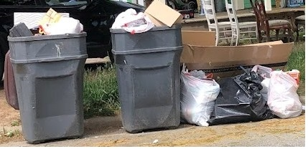
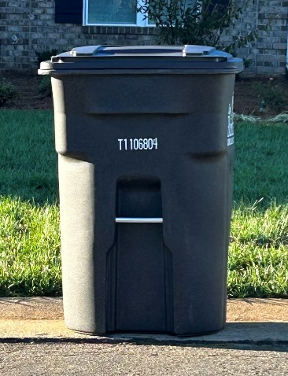
ACCEPTABLE FOR DISPOSAL

If an additional cart is desired, please contact the Solid Waste Management Division at 336-349-1074 for fees and scheduling delivery. Each cart has a one-time fee of $61.50 for the roll cart and the tipping fee is $6.64 per month per cart (two cart maximum per residence). These prices and fees are for Fiscal Year 2023-2024 and are subject to change. If you move, please notify us as well so that we can update our records.
Bulk Items
All disposal of bulk trash is subject to approval by the Solid Waste Superintendent. Bulk trash is classified as furniture, couches, chairs, beds, dressers, tables, mattresses, toilets or other large items that will not fit in the rollout trash cart. All loose or bagged items must be placed in the rollout trash cart for disposal. Do not mix bulk items with yard waste or brush. Bulk service will not be provided to commercial properties that do not have trash service with the City of Reidsville.
UNACCEPTABLE FOR DISPOSAL
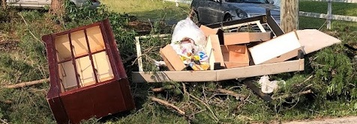
UNACCEPTABLE FOR DISPOSAL
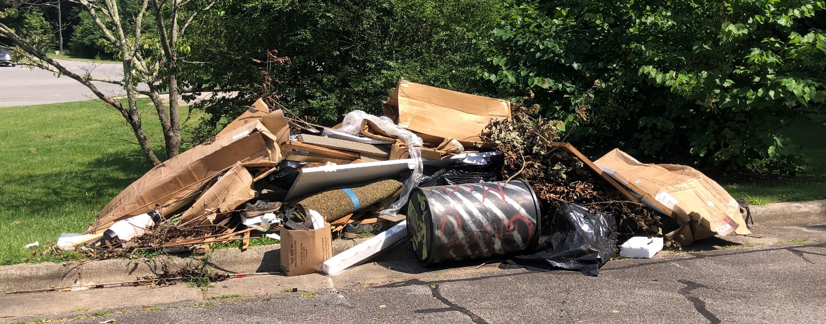
Items we do NOT collect:
- Construction materials (concrete, brick and lumber)
- Tires
- Liquid Paint
- Pesticides/other household hazardous materials or chemicals
- Televisions/Computers
- Propane gas cylinders
- Pallets
The resident or homeowner is responsible for proper disposal of these materials.
Yard Waste (Leaves and Grass)
Yard waste must be bagged and placed at the curb for collection by the Solid Waste Management Division’s Yard Waste Truck. Do not mix yard waste with household garbage, brush or bulk items.
In November and December only, the Public Services Division will collect loose leaves at the curb. All other times of the year, leaves must be bagged and placed at the curb for collection. Do not mix bagged leaves with loose leaves as this can damage City equipment and result in lost productivity.
ACCEPTABLE FOR DISPOSAL
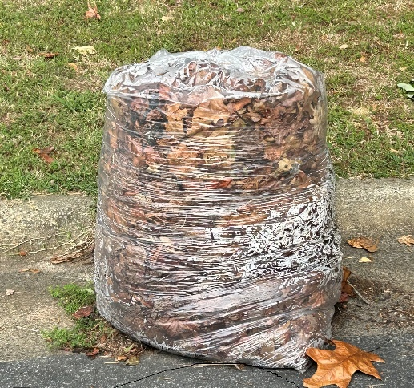
Brush (Tree Limbs)
Disposal of tree limbs and brush is limited to three (3) cubic yards per week to help maintain our route schedules. Tree limbs and brush may not exceed six (6) feet in length and six (6) inches in diameter and must be placed at the curb for collection. All brush must be clear of parked cars, power lines, phone lines and fire hydrants. Do not mix brush with household garbage, bulk items and yard waste.
This service is for homeowners only. All brush, limbs, trees or any other debris generated by contracted tree service companies, landscapers and lot clearing will not be picked up by the City of Reidsville. The disposal and cost of any debris generated by a contracted business will be the responsibility of the contractor or homeowner.
UNACCEPTABLE FOR DISPOSAL
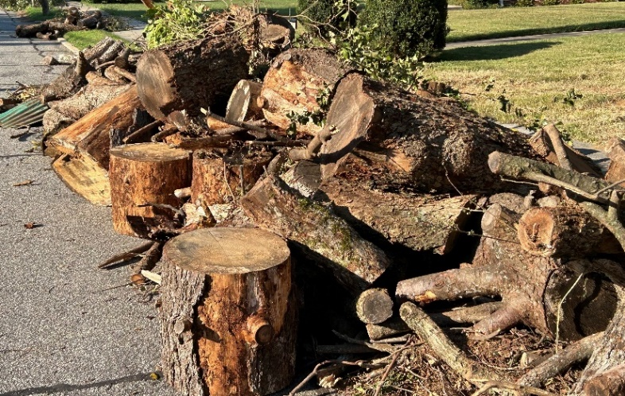

ACCEPTABLE FOR DISPOSAL
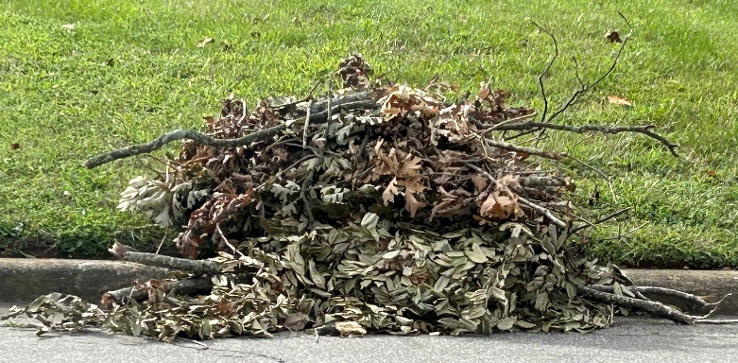
Construction and Remodeling Waste
A self-service container is located at our Transfer Station Operations Site (709 Marcellus Street). Operational hours are Monday-Friday 7:00 A.M. to 3:00 P.M. with the exception of approved holidays. The container is designed for City residents to drop off waste building materials from homeowner projects only. No commercial builders, roofers or contractors are permitted to use this location.
The following items cannot be dropped off due to County landfill restrictions:
- liquids, paints or fluids of any kind
- pressure cylinders, gas grill tanks or canisters
- hazardous waste
- motors, engines or car parts
- metal
- batteries
- tires
- pallets
- cardboard
- yard waste, dirt, rock, brick or concrete
- furniture or carpet
There is also small scale recycling at the Transfer Station Operations Site. This is a drop-off center for City residents only. This service is not intended or permitted for commercial business use.
The following items are accepted for recycling:
- TVs
- Computer monitors
- Used motor oil
- Used cooking oil
Commercial Refuse Collection
Commercial refuse is manually picked up by the Solid Waste Management Division. All commercial customers are required to purchase their own trash receptacles. Trash receptacles should be out and ready for disposal by 3 A.M. on your collection day. For cost, regulations and to start service, contact the Solid Waste Division at 336-349-1074.
Curbside Recycling
The City of Reidsville offers voluntary curbside recycling at your residence for City residents through a contract with Foothill Waste Solutions.
Accepted items:
- Office and school papers
- Catalogs, phone books and magazines
- Newspapers and paper bags
- Plastic bottles, jars and jugs
- Clean aluminum and tin cans
- Corrugated cardboard
For cost and to start service, please contact Foothill Waste Solutions at 336-871-4055.

