Roaming Around Reidsville

By Angela G. Stadler

Public Information Officer

City of Reidsville

Any time you work for an organization for any length of time, faces change as people come and go. These days people seem more likely to spend five years with one employer rather than make it a lifelong career. Donna Setliff, the City of Reidsville’s Community Development Manager, is one of those special exceptions.

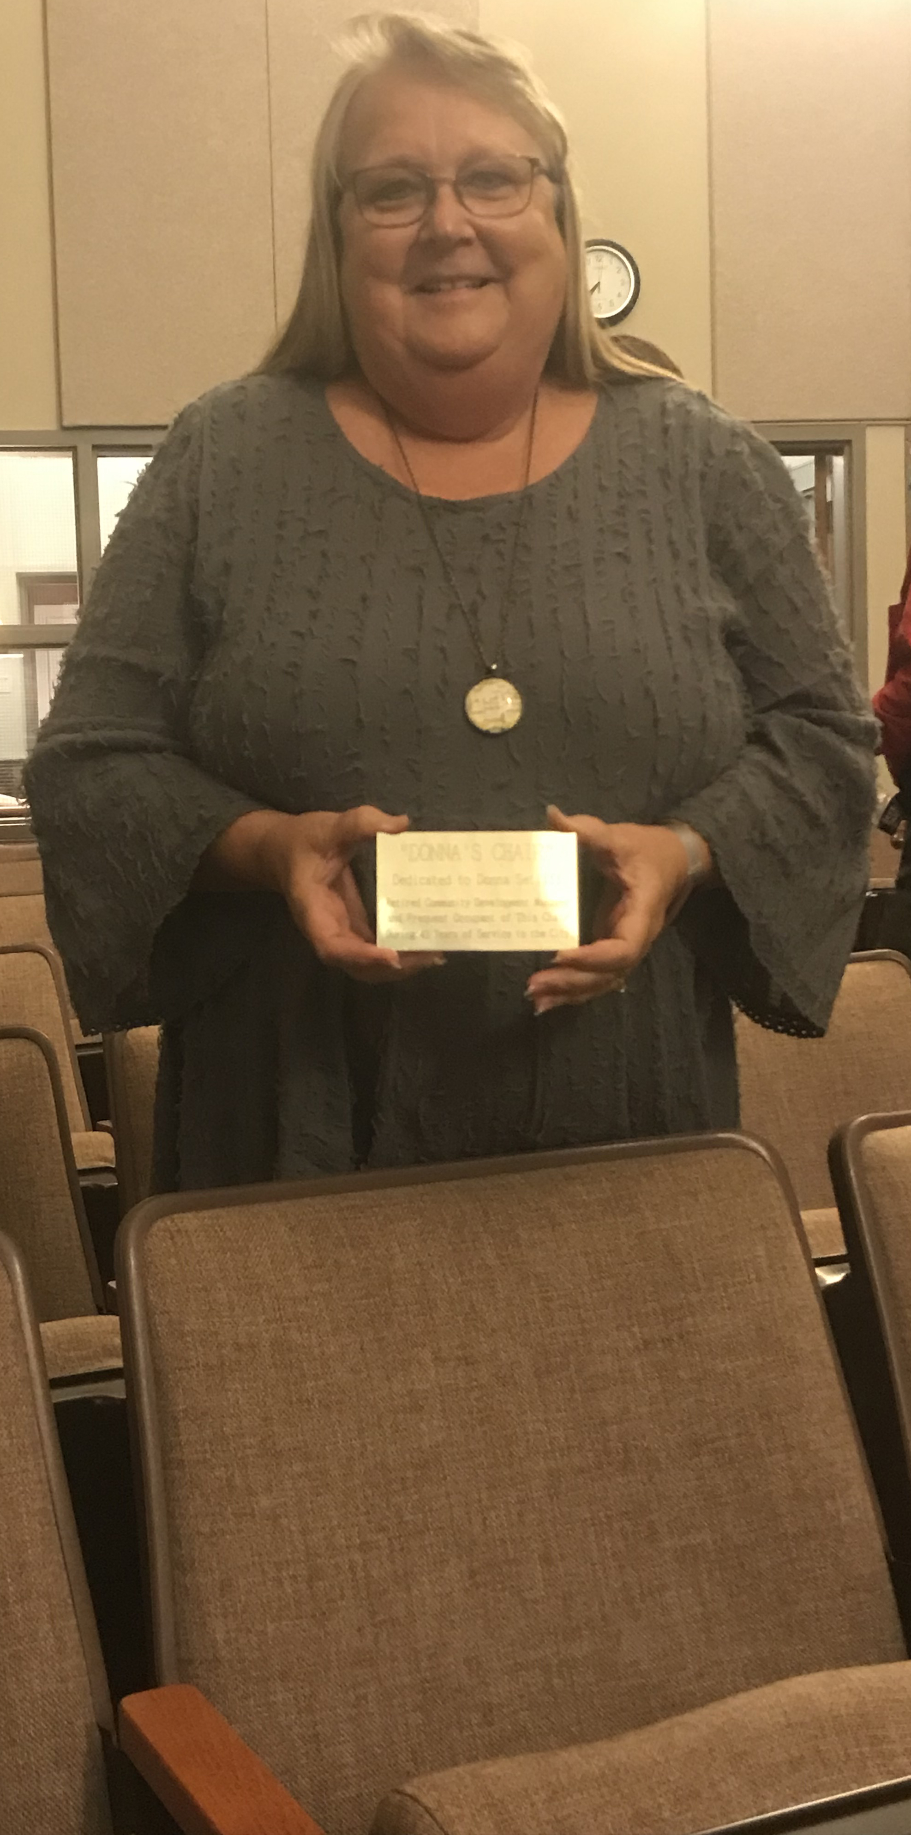
Donna retired from the City last month with 41 years of service. It is hard to imagine someone spending that much time in one place, but Donna has always been an integral part of Team Reidsville. Often, it was a thankless job … many times, she would have to tell people why they couldn’t do things because it was against the City’s Zoning Ordinance or the State Building Codes. But Donna was devoted to her job, to the City of Reidsville and its citizens.
Donna Setliff

At her final Council meeting November 9th, Donna was understandably emotional. She had stood at that podium so many times over the decades, reporting to Council on proposed changes to text amendments, Special Use Permits and the like, as well as annexations and demolitions. Realizing it would be her last time before retirement, she got choked up, making those of us who were listening a little teary-eyed as well.

It was very fitting that a developer there for an item on the agenda talked of how fantastic she had been to work with on their project. Donna’s professionalism and her wealth of knowledge and expertise on all things planning and zoning in the City of Reidsville will be hard to replace.

The Reidsville City Council recognized her devotion. At that last Council meeting, they deviated from their written agenda to surprise her with a plaque that will go on a chair in the Council Chambers – a chair that Donna has spent a lot of time in during her 41 years of service to the City. The plaque reads:

“DONNA’S CHAIR”

Dedicated to Donna Setliff

Retired Community Development Manager

and Frequent Occupant of This Chair

During 41 Years of Service to the City

So, if you ever find yourself in City Council Chambers at City Hall, look for the plaque on the second chair on the first row on the right-hand side of the aisle. It will be a very hard seat to fill.

In other news around the City of Reidsville:

City Event Hotline.

Remember, the City’s Main Street Department has set up an event hotline that lists upcoming events sponsored by the Reidsville Downtown Corporation and City throughout the month. You can call 336-347-2381 to find out what’s happening in the downtown area and around Reidsville.

Holiday Lighting Contest.
Unfortunately, by the time you read this, it will most likely be too late to participate, but the Reidsville Appearance Commission is hosting a Holiday Lighting Contest. If you’re inside the City limits, you can choose from three different categories for a chance to win a $50 gift card. Applications are due by December 1st with the winners to be announced December 20. To receive the application and any additional info, residents were to contact Briana Perkins at 336-349-1065 or email her at blperkins@ci.reidsville.nc.us. If it’s too late, at least you can enjoy the beautiful lights throughout Reidsville for the holidays!

Decorating for the Holidays.

As we mentioned last month, don’t forget to stop by our downtown shops to check out the holiday décor. Many of our local merchants will be participating in the Downtown Business Decorating Contest and will be decked out for the holidays. The windows will be judged during the first week in December.

Annual Tree Lighting.
Traditionally the Annual Tree Lighting in downtown Reidsville, sponsored by the Reidsville Downtown Corporation, has taken place in November, but this year, “Hometown Christmas” kicks off on Friday, December 3. This year’s event will be held on South Scales Street from 6-9 p.m. with Santa taking up residence at Market Square, which will be beautifully decorated for the holidays. There will be dance groups, food, hayrides, the outdoor movie, “Elf”, will be shown with marshmallow roasting and a Santa’s Workshop at the Reidsville Chamber of Commerce. It should be a lot of fun!
Holiday Market.
Got that Christmas shopping done? You might want to stop by the Holiday Market on Saturday, December 4, at The Penn House, 324 Maple Avenue (enter at the back from the parking lot off Irvin Street). Local artisans will be setup selling all kinds of Christmas gifts. A special treat is The Penn House will be fully decorated! Hours are from 9 a.m. until 2 p.m.

Historic Walking Tour.
Another Downtown Lantern Historic Walking Tour, like that held in December of 2019 prior to COVID, is planned for 6 p.m. on Saturday, December 4. Led by the City’s Historic Preservation Commission, the tour is free, but tickets are required to get accurate numbers for the event to ensure there are enough tour guides. To see if tickets remain, you can go online at https://bit.ly/3CulsEe.

Winter Coat Drive.
The Reidsville Parks & Recreation Department will hold its 4th annual Pay It Forward Winter Coat Drive through December 10. They will accept new or gently used items, including coats, scarves, hats & gloves, of all sizes. All donations can be dropped off at the Parks & Recreation Department, 201 N. Washington Avenue through Friday, Dec. 10. Items will be given out to the community on Saturday, December 18, beginning at 9 a.m. at the P&R Department. For more information, you can call 336-349-1090.

Reidsville City Council Swearing In.
With this year’s elections, the City of Reidsville will have a new Mayor. Councilman Donald L. Gorham was elected as Mayor so he will be sworn in during the Council’s December 14th meeting at 6 p.m. Also re-elected were at-large candidates Harry L. Brown and Terresia Scoble. In addition to the swearing in of these Council members, outgoing Mayor Jay Donecker, who opted not to run again, will be recognized. To allow more space for social distancing, the meeting and reception to follow will be held at RCARE/Senior Center, 201 North Washington Avenue, instead of Reidsville City Hall. The public is invited.

City Offices Closed for the Holidays.

Reidsville City Offices will be closed December 22-24 for the Christmas Holiday and Friday, December 31, for New Year’s. Check the City website, reidsvillenc.gov, or the City’s social media to check trash pickup schedules or you can call 336-349-1070.

