**Roaming Around Reidsville**

**By Angela G. Stadler**

**Public Information Officer**

**City of Reidsville**

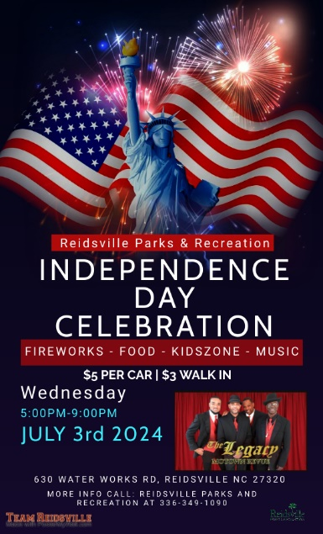The Reidsville Parks & Recreation Department continues a July 4th tradition again this year … the annual Independence Day celebration at Lake Reidsville, 630 Water Works Road. You’ll notice that it is called Independence Day because the City of Reidsville doesn’t typically hold its event on July 4th.

Many years ago, due to the exploding price of fireworks, the City opted to hold its celebration on a date other than the 4th of July. The pyrotechnics company gave us a discount on the fireworks, which, in turn, meant we were able to provide an even nicer show. For many of our residents, they like the different date so that they can go to other area shows or family celebrations on July 4th.

This year the Independence Day Celebration at Lake Reidsville will be held from 5-9 p.m. on Wednesday, July 3, 2024. As usual there will be food vendors, street performers and a KidsZone with bounce houses, slides and giant games. The musical headliner will be *The Legacy* band, which provides a spectacular Motown Revue that will begin at 6:30 p.m. The band will perform until shortly before 9 p.m.

Following the show, the band will sing the National Anthem as the fireworks begin at approximately 9 p.m. The park typically closes by 8:15 p.m. so you need to get inside the park area before then. The cost to get in is $5 per car and $3 per walk-in.

The Reidsville Police Department and Parks & Rec personnel have gotten really good at getting cars out of the park really quickly after the show ends. We hope you will be able to enjoy us for one of Rockingham County’s best firework displays!

**The Area’s Transportation Needs.**

The City of Reidsville, actually all of Rockingham County, wants your help in identifying the area’s transportation needs.

The Rockingham County Comprehensive Transportation Plan (CTP) is a long-range plan, which identifies major transportation improvement needs and develops long-term solutions for the next 25 to 30 years. The study is a joint effort between Rockingham County, the Piedmont Triad Rural Planning Organization (PTRPO), and the North Carolina Department of Transportation -Transportation Planning Division (NCDOT TPD). This plan is an update of the adopted 2014 Rockingham County CTP, Western Rockingham CTP, and Eden CTP. It includes the City of Eden, the Town of Madison, Town of Mayodan, the City of Reidsville, the Town of Stoneville, the Town of Wentworth, and Rockingham County.

This plan update will evaluate current and future conditions for highway, bicycle, pedestrian, and public transportation modes. Please help us all of us by going to the online survey and filling it out at <https://metroquestsurvey.com/d9b2r>. The survey will be open until July 21st. If you have any questions, you can contact Dawn Vallieres at [dvallieres@ptrc.org](mailto:dvallieres@ptrc.org) or call her at 336-904-0300.

**In Other News:**

Activities and events will continue throughout the month of July. Find out more by checking out City of Reidsville social media or the City website, reidsvillenc.gov. Here are a few of the planned events throughout the month:

* **The Downtown Farmers Market** at Market Square continues on Thursdays and Saturdays from 7 a.m. until 1 p.m. The market offers fresh produce, baked goods, plants, jellies, eggs & more and accepts cash, credit, debit and EBT.
* **July 3rd** – **The Independence Day Celebration** is set for 5-9 p.m. at Lake Reidsville with fireworks starting around 9 p.m.
* **July 4th** – **Reidsville City Offices** will be closed for the holiday.
* **July 12th** – The **Second Friday Downtown series** holds its third event of the year from 5-7:30 p.m. The previous two events were held in a downtown parking lot off of Gilmer Street, but this time, the Reidsville Downtown Corporation is closing Gilmer Street between Scales and Southwest Market streets. Among the activities planned are music, food and games. Come and shop downtown while enjoying “Rock It in Reidsville”.
* **July 13th** – A **Team Bass Tournament** is slated at Lake Reidsville. Call the lake at 336-349-4738 for details.
* **July 20th** – The **Summer Concert Series** kicked off last month with 90s music but in July, “Ace Party Band” returns to Market Square in downtown Reidsville with blues, country, hip hop, jazz, pop and R&B. Bring a lawn chair and enjoy the free music from 7-9 p.m.