Roaming Around Reidsville

By Angela G. Stadler

Public Information Officer

City of Reidsville

Last month we talked about walkability for our residents, concentrating on the City’s greenways plan. For the past 20 years, the City has been creating and implementing a cohesive greenways network to provide walkability for our residents and address this quality-of-life issue.

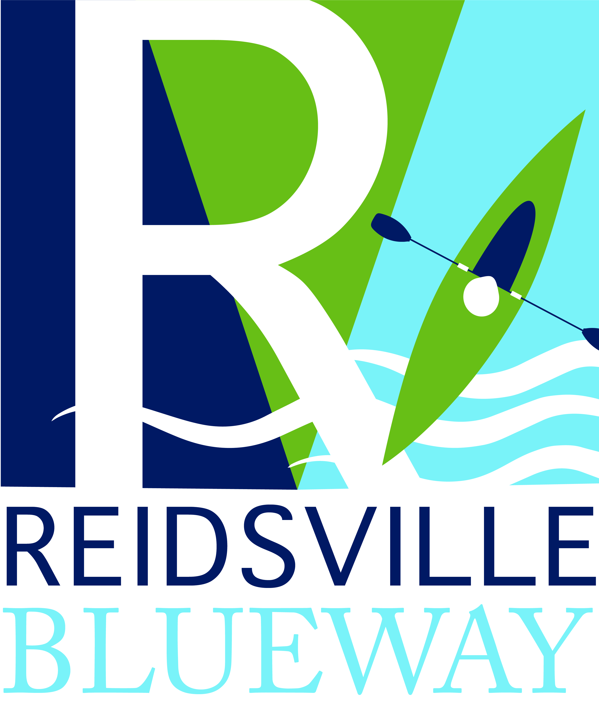
I promised you this month we would talk about the other part of the City’s overall plan – the City’s blueways. While the City’s greenways have been decades in the making, Reidsville’s focus on blueways has evolved in just the past few years.

At its 2018 retreat, the Reidsville City Council instructed staff to begin not only updating the City’s greenways plan but to also expand the plan to include blueways. When discussing rivers, one tends to think of other parts of Rockingham County rather than Reidsville. Reidsville is considered more when you think about lakes, such as our beautiful Lake Reidsville and rustic Lake Hunt, but of course, we have creeks that feed into the lake.

And that’s where our latest blueway access points have come into play. Back in May of this year, the City officially opened our first Lake Reidsville Blueway access point at 1266 McCoy Road. The access point includes a trail, stairs and launch site for kayaks and canoes. Part of a generous $30,000 donation by Pella Corporation to the City was used for the access point.

Before this, the only place to launch a kayak or canoe in Reidsville was at Lake Reidsville or Lake Hunt. Future plans are to have Blueway Trailheads at US 158 and Iron Works Road, but both of those are still in the planning stages. A Blueway Trail is also recommended on the Haw River at the Southern States store along US 29 Business, which would go to a proposed Blueway Trailhead at NC 150. A Lake Hunt Blueway is also being planned that would connect Lake Hunt park to a trailhead in the Irvin Farm Road area. Currently you can kayak and canoe directly from the Lake Hunt park.

We are very excited about the expansion of the City’s Greenways & Blueways network in the coming years. Especially as we continue to fight the battle against COVID-19, it is great to have recreational activities available for our citizens and visitors that can be shared in small family groups or enjoyed by individuals.

In other news, there are a lot of events going on in Reidsville throughout the month of September, plus a new event hotline.

City Event Hotline.

The City’s Main Street Department has established an event hotline that will list upcoming events sponsored by the Reidsville Downtown Corporation and City throughout the month. You can call 336-347-2381 to find out what’s happening in the downtown area and around Reidsville, but the hotline will be for City-sponsored events only!

Athletic Registrations.

September 10th is the deadline for several sports registrations by the Reidsville Parks & Recreation Department. The following are open until then: Flag Football (ages 4-7); Contact Football (ages 7-9 & 10-12); Cheerleading; and Adult Volleyball. You can learn more by calling the Rec Department at 336-349-1090 or you can register at the online site, http://activenet.active.com/reidsvillerec.

2nd Downtown Fridays!

Friday, September 10, will be the final 2nd Downtown Friday event for the year. It will be your last opportunity to hear music, enjoy the kid’s zone and food vendors and view those wonderful vintage vehicles along Scales Street. The Reidsville Chamber of Commerce will be providing a Beer Garden during the event. Hours are 6 p.m.-9 p.m., rain or shine.

9/11Memorial Dedication.

On the 20th anniversary of an event that changed us all forever, the City of Reidsville will unveil a new 9/11 Memorial at the front of Reidsville Fire Station #1, 402 South Scales Street, beginning at 11 a.m. on Saturday, September 11. The Memorial will consist of a beam from the Twin Towers, and cutouts sculpted and donated by area artist Jim Gallucci, which will remember all the lives lost on that fateful day and will honor First Responders. Thanks so much to Mr. Gallucci and Rickey Loye for their donations to this project!

A Historic Downtown Stroll.

The Reidsville Historic Preservation Commission put on a fabulous downtown historic lantern walk back in December of 2019. The success of that venture has prompted the HPC to create a new historic downtown stroll, which will take place on Saturday, September 18th, at 10 a.m. Registration for the event will be available on EventBrite. While the stroll is free, the Commission needs to get a headcount so that there will be enough tour guides. It should be lots of informative fun!

Customer Appreciation Week.

Downtown businesses, in conjunction with the Merchants Association, will hold “Customer Appreciation Week” September 20-25. More information will be available on the Downtown Market Square Facebook page or by calling the City’s new event hotline at 336-347-2381.

Water Lantern Festival.

The Water Lantern Festival returns to Lake Reidsville, 630 Water Works Road, Reidsville, on Saturday, September 25. Gates open at 4 p.m. for this ticketed event, which will continue until 9 p.m. To learn more, you can go to www.waterlanternfestival.com.

Concerts on the Square.

The Summer 2021 concert series at Market Square, 303 S. Scales Street, in downtown Reidsville will conclude with Pop and Top 40s music provided by the Ace Party Band. The concert will start at 7 p.m. and last until 9 p.m. on Saturday, September 25. Don’t forget to bring your chair. The Chamber of Commerce will provide a Beer Garden at the concert. You can go to www.reidsvillenc.gov or the Downtown Market Square Facebook page to find out more.

Fitness on the Square.

“Fitness on the Square” at Market Square in downtown Reidsville, which began in May, ends on Thursday, September 2nd with the 6:30 p.m. “Bootcamp” class. We appreciate the partial funding from Cone Health for this annual exercise program.

Farmer’s Market.

The Farmer’s Market at Market Square in downtown Reidsville continues to be open! Come get your fresh veggies and more at the market, open from 7 a.m. until 1 p.m. Saturdays, Tuesdays & Thursdays. EBT customers can double their benefits with no cap!

