Roaming Around Reidsville

By Angela G. Stadler

Public Information Officer

City of Reidsville

The City of Reidsville got its first snow of 2022 last month. Luckily it wasn’t as bad as first predicted although as I was writing this column, we were waiting on a second wave, which might include more snow. Like many of you, I love to see that first beautiful snowfall of the season, but I quickly grow tired of the problems that can come with it, including icy roads and possible power outages.


After a really mild winter so far, the City of Reidsville’s Public Works Department faced its first inclement weather test the third weekend of January. The work of our Public Works employees is always a necessity, but especially in cases of inclement weather. In every season, they can be seen on the streets repairing broken water lines, filling pot holes and, of course, scraping City streets when wintry weather hits. Our Public Works Department has been especially taxed this year, finding it hard to locate temporary helpers for leaf collection as well as full-time employees. Add in the shortages experienced because of COVID, and you have a reduced workforce the likes of which we have probably never seen before. With the recent snow and ice, our Public Services Division had to call on their co-workers in Sanitation to help clear the streets. Go TEAM REIDSVILLE!

While we are safe in our homes, these workers are out braving hazardous conditions to get our roadways brined and salted. And while many of our citizens are understanding and complimentary of their efforts, others are quick to find fault with the results. I don’t know about you, but I am glad that we can depend on those workers, along with NC Department of Transportation and Duke Energy employees and our Police & Fire, to help prepare us for what’s coming, even when the weatherman doesn’t get it right.

So, if you see a Public Works employee out and about, thank them for what is often a thankless job. As we find it challenging to recruit for such positions, we must constantly remind our applicants of the wonderful long-term benefits of working with the City. The benefits package is great for those looking not just for a job but for a lifelong career.

If you are interested in a position with the City of Reidsville, we have a lot of openings right now. Go to https://jobs.reidsvillenc.gov/ and check out the postings. You may find something that you’d be a perfect fit for and might land up with a new position in City government. I can attest that there is no better job than working for the City of Reidsville and being a part of the team. Come join us!

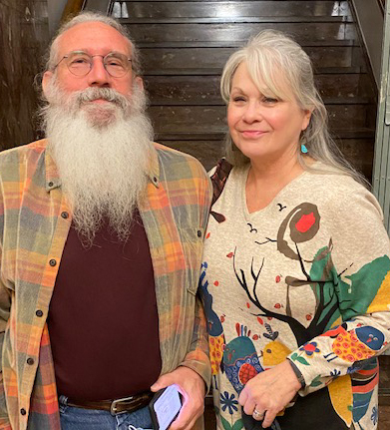
Retired Deputy City Clerk Cindy Farris.
Deputy City Clerk Cindy Farris, shown with husband, Ron, retired last month from the City of Reidsville and was recognized by the Reidsville City Council at its January 2022 meeting. Congratulations Cindy!
I’d also like to give a “shout out” to retired Deputy City Clerk Cindy Farris. Cindy retired at the end of December with nearly 14 years of service to the City of Reidsville. Cindy’s smile and wonderful demeanor was an invaluable asset not only for our office but also for the entire City. She was the first face many of our citizens saw here at City Hall, and she also served as the staff liaison to the City’s Human Relations Commission while here. In everything she did, she was the epitome of customer service and will be hard to replace. The Reidsville City Council recognized Cindy at its January 11th Council meeting and thanked her for her years of service. She will be missed!

In other news around the City of Reidsville:

Holiday Decoration Contest.

Congratulations to Demond Williams, Christie Sanford and Cindy Chmielecki, winners of the Reidsville Appearance Commission’s Holiday Lighting Contest. These winners did a great job decorating for the holidays and received a gift card for their efforts. We can’t wait to see what they do next year!

Rockingham County Senior Games.

Registration for the Rockingham County Senior Games is slated to kick off on February 1st with registration packets being available that day. Each Senior Center in the County will host a kickoff event on March 18 from 10 a.m. until 12 noon.

Tax Assistance.

Our Senior Center/RCARE at 201 North Washington Avenue, Reidsville, will begin providing tax assistance beginning February 1st, but you must call 336-349-1088 to make an appointment. You can always check out RCARE’s Facebook page for updates on ongoing programs and events.

Basketball Registration.

Basketball for ages 7-9 started January 31st at the Reidsville Parks & Recreation Department, 200 N. Franklin Street. Registration for ages 10-12 and 13-17 is still available through February 4th. You can call 336-349-1090 or register online at https://apm.activecommunities.com/reidsvillerec/Home. You can go to Reidsville Parks & Rec’s Facebook page for updates on ongoing programs and events.

Activities at Lake Reidsville.

The monthly disc golf tournament on the Lake’s Edge course at Lake Reidsville, 630 Water Works Road, is planned for February 27. You can call Lake Reidsville at 336-349-4738 for more details. Bass and catfish tournaments at the lake are being planned for March. You can check the Lake Reidsville Facebook page for more info!

Event Hotline.

Due to the weather and winter season, there aren’t many City downtown events slated for right now. However, when there are, you can check out the Downtown Reidsville Event Hotline to find out about upcoming events. You can call 336-347-2381 to find out what’s happening.

Board & Commission Openings.

As I noted last month, the City of Reidsville is always looking for residents committed to their community and willing to serve on our boards and commissions. All positions are appointed by either the Mayor or the Reidsville City Council. Interested? You can check out the openings on the City website, www.reidsvillenc.gov.

